**Article Title**

(Center alignment, Times New Roman 16 pt, Bold, Capitalize every first word, maximum 16 words)

## **A.Author1, B.Author2, C.Author1,D.Author3, E.Author2**

1Afflitiation: Department, Organization Name, Country

2Afflitiation: Department, Organization Name, Country

3Afflitiation: Department, Organization Name, Country

email correspondence: [your@email.com](mailto:your@email.com)

|  |  |
| --- | --- |
| Abstract | |
| The abstract should be typed in Times New Roman, 11 pt font, single-spaced, and justified. It consists of the background of the problem, research objectives, methodology, main findings (including any new facts), and the main conclusions. Recommendations for further research is recommended but not obligation. The abstract should be written in English and should be between 100 and 150 words. | |
| Keywords: | Keywords consist of three to five words or phrases; separated by semicolon |

DOI: (will be provided upon production stage)

Article history:

|  |  |
| --- | --- |
| Submission | : |
| Reviewed | : |
| Revised | : |
| Copyedited | : |
| Published | : |

# Introduction

The Introduction should begin with a general background of the research topic, providing context and establishing urgency and rationale for the study. Relevant and current literature should be incorporated to provide context and highlight the research gaps, ensuring that references are original and directly related to the research topic. The presentation should be coherent chronologically and the logical relationship between one paragraph and the following paragraph should be clear.

# Methods

In the research method, the author explains the research location, sample design, measurement (such as research instruments adapted to the type of research), data collection design, and data analysis techniques. The explanation of research methods is concise, clear and complete.

# Result

The results section presents the results of the research. Research results can be supplemented with tables, graphs (pictures), and / or charts.

# Discussion

The discussion section describes the results of data processing, interpreting the findings logically, linking them with relevant reference sources.

# Conclusion

The conclusion section summarizes the key findings of this research. The section may include research limitations and suggestions for improvements, as well as recommendations for future research and policy changes. The conclusions should be written critically, carefully, logically, and honestly, based on the facts obtained. The conclusion should be presented concisely in no more than two paragraphs and avoid lists of conclusions in bullet or number form.

# Acknowledgements

The Acknowledgement section may be included if necessary and should be presented concisely in no more than one paragraph. This section is intended to acknowledge contributions from individuals or institutions that have supported the research. Avoid using lists, and instead, integrate all acknowledgments into a coherent and well-structured paragraph

# References

Authors are encouraged to use Mendeley or Zotero Reference Manager Software. The citation and reference formatting should follow the American Psychological Association (APA) Style guidelines. While it is not necessary to have an extensive list of references, a minimum of 15 references is required, with at least 70% of them from journal articles. Journal article references are recommended to be no more than 10 years old, except for books, which may be older if they remain relevant.

Table 1 Data

|  |  |  |
| --- | --- | --- |
| Number | Informant | Information |
| 1 | Mr Hamid | Head village |
| 2 | Mrs. Siti | Secretary village |
| 3 | Mr Robi | Sub-District Head |

Source: Explained, Year

Figure 1 Figure

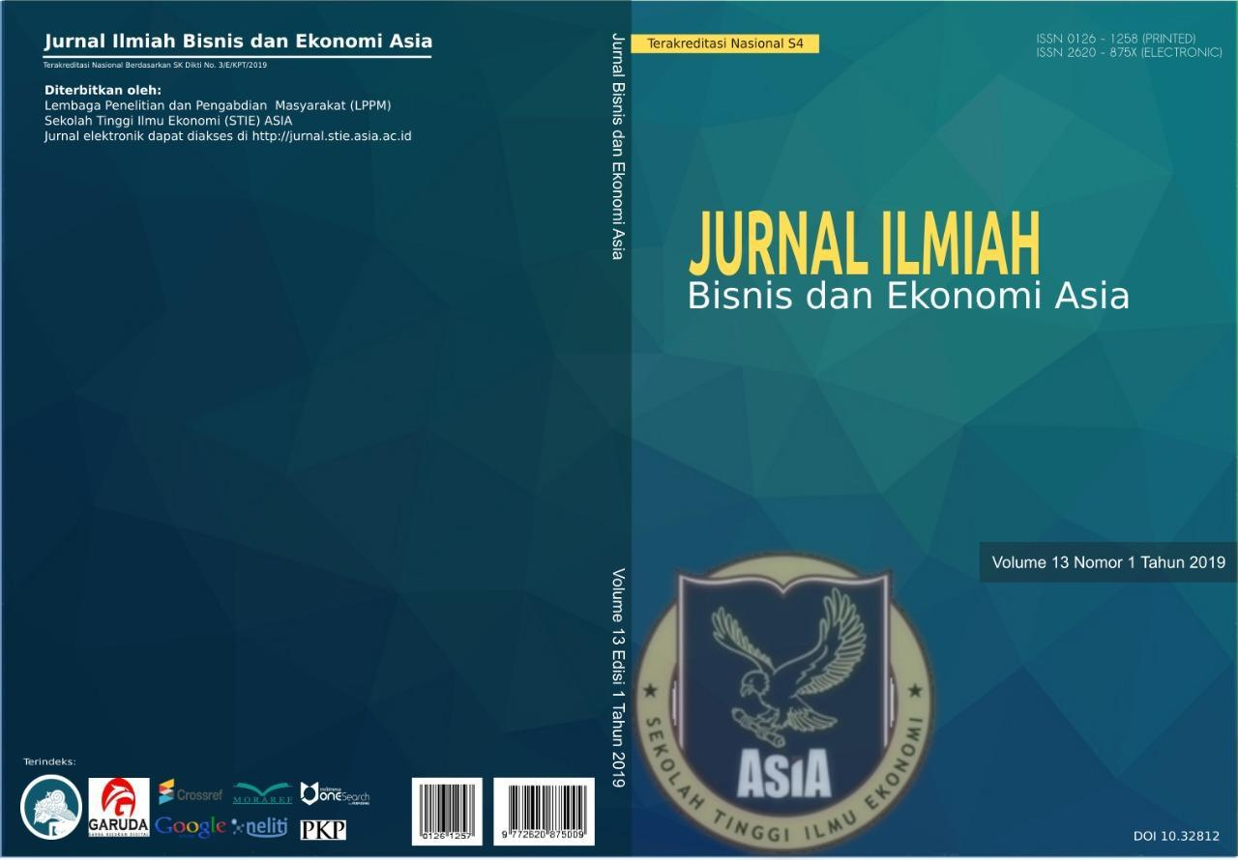Source: Explained, Year

# Formula

Author is suggested to use the equation editor in the typing formula. The formulas should be located on the left where the caption number is at the end of the right margin which is preceded by periods along the formula and description number.

Y = α + β1.X1it + β2.X2it + β3.X3it + β4.X4it + β5.X5it + β6.X6it 1