Write the Title Briefly, Clearly, Concisely, Interesting, and Describing the Content Maximum 15 words, Sentence case, bold, 14pt size

(Subtitle 12pt size, capital first letter can be used when needed)

# Abstract

The abstract is a mini representation of the entire article. Make sure the abstract includes in a concise manner: Research objectives, which represent the primary research questions that require resolution; Research methods in conducting the research outline; The most significant results/findings of the research; The main implications of the research findings; Research Limitations (if any); The abstract should between 100 to 200 words.

Keywords: Choose 3 to 5 words or phrases that are most relevant and accurately reflect the topic, methodology, and key findings of the research. In determining keywords, consider technical terms, key concepts, and variables that are an important part of the research. Separate every keyword with semicolons.

# 



# Introduction

The Introduction should begin with a general background of the research topic, providing context and establishing urgency and rationale for the study. Relevant and current literature should be incorporated to provide context and highlight the research gaps, ensuring that references are original and directly related to the research topic. The presentation should be coherent chronologically and the logical relationship between one paragraph and the following paragraph should be clear.

# Research Methods

The research methods section should present the experimental procedure in detail and systematically so that it can be reproduced by other researchers and produce consistent findings. If the procedure refers to previous research, appropriate and accurate references must be included. The description of the methodology should be clear and complete, including all steps, materials, and equipment used. Authors are also encouraged to include information on supporting materials or additional relevant details to strengthen the reproducibility and validity of the study.

# Result

Present the research results neatly, completely, and systematically. Use tables, figures, and schemes that are clear, easy to read, accurate, and have sufficient resolution to visualize the findings. Each piece of data presented must be logically connected to the discussion, ensuring that the meaning and impact of the research findings can be interpreted correctly.

# Discussion

The flow of the discussion should have a clear structure, gradually directing attention to the key points on which the research conclusions are based. Conduct a thorough comparative analysis between the research results and previous studies, especially those discussed in the introduction.

# Conclusion

The conclusion section summarizes the research's key findings by addressing the objectives of the study. Present the results of the research data and analysis that support the conclusion statement. The section may include research limitations and suggestions for improvements, as well as recommendations for future research and policy changes. The conclusions should be written critically, carefully, logically, and honestly, based on the facts obtained. The conclusion should be presented concisely in no more than two paragraphs and avoid lists of conclusions in bullet or number form.

# References

Authors are encouraged to use Mendeley or Zotero Reference Manager Software. The citation and reference formatting should follow the Vancouver Style guidelines. While it is not necessary to have an extensive list of references, a minimum of 15 references is required with at least 70% of them from journal articles. Journal article references are recommended to be no more than 7 years old, except if they remain relevant.

Table 1 Data

|  |  |  |
| --- | --- | --- |
| Number | Informant | Information |
| 1 | Mr Hamid | Head village |
| 2 | Mrs. Siti | Secretary village |
| 3 | Mr Robi | Sub-District Head |

Source: Explained, Year

Figure 1 Figure

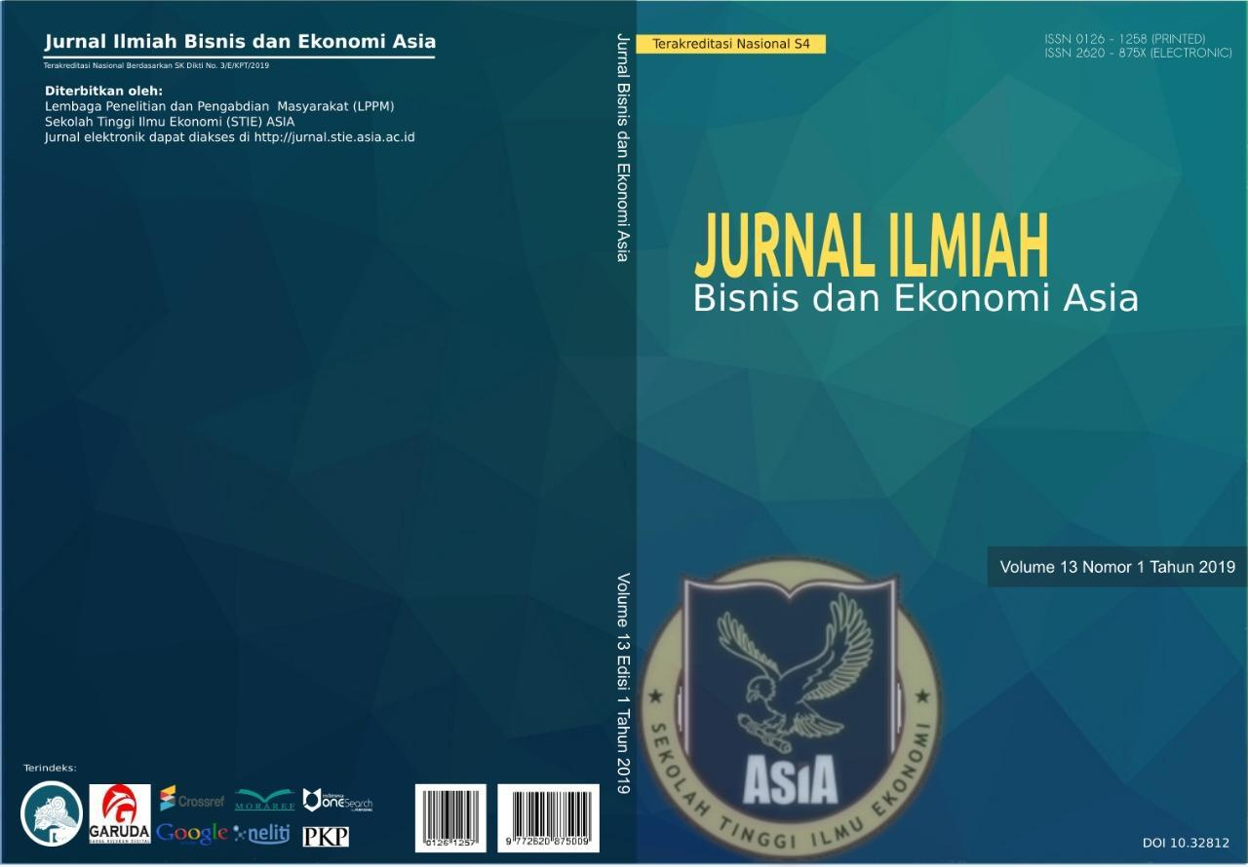Source: Explained, Year

## Formula

Author is suggested to use the equation editor in the typing formula. The formulas should be located on the left where the caption number is at the end of the right margin which is preceded by periods along the formula and description number.

Y = α + β1.X1it + β2.X2it + β3.X3it + β4.X4it + β5.X5it + β6.X6it 1

## Quotations

Quotations are used to support arguments, provide evidence from reliable sources, or refer to important definitions or concepts.

Short Quotations (Less than approximately 30 words - check specific journal guidelines):

* Integrate the direct quotation into your text and enclose it in double quotation marks (" ").
* Immediately follow the quotation with a citation, which in Vancouver style is a number in parentheses or superscript that corresponds to the entry in your numbered reference list.

Example:

"Capital market efficiency implies that security prices fully reflect all available information" (1, p. 383).

Long Quotations (Approximately 30 words or more)

* Separate the quotation from the main text in a block quote.
* Start the quotation on a new line and indent the entire block quote to the left (0.5 inches or 1.27 cm).
* Use left alignment paragraph.
* Do not use double quotation marks at the beginning and end of the block quote.
* The entire block quote should be italicized.
* The citation follows the final punctuation mark of the block quote.

Example:

Porter's (2) research on competitive advantage states:

The value chain disaggregates a firm into its strategically relevant activities to understand the behaviour of costs and the existing and potential sources of differentiation. A firm gains competitive advantage by performing these strategically important activities more cheaply or better than its competitors. (p. 33)